ETE (Great Lakes Section) 1221 mm X 610 mm MODULE SPECS.

This specification defines a module that is 1221 ± 5 mm long. (approx. 4 feet) and 610 mm wide (deep) at the ends (approx. 2 feet).

Purpose:
The purpose of this specification is to define the construction of modules with a European (all of Europe) theme with the intent of attaching them together for the purpose of entertaining people and to have some fun. If you’re into completely prototypical operation these modules may lead to disappointment. On the other hand, if you’re into having some fun and entertaining people with the idea of encouraging them to join in the fun, you’ll probably love it. Also, if you have some completely crazy idea for a module that breaks all the rules, tell us about it first – rules are meant to be broken.

Definitions:
- Left and right are defined from the perspective of the operator inside the layout while viewing the module from the top, i.e. the side with the track on it.
- Approximately means just that. We’re not all genius woodworkers – do your best.
- 25.4 mm = 1 inch
- “Entertaining people” means that after they see the layout, they walk away smiling, happier than when they came.
- “Having fun” means we don’t have any “epoch police”, nor encourage “rivet counters”, nor do we try to advance any political or other personal agendas.
- Roadbed – the builder supplied ballasted area under the track bed. This is NOT the plastic ballast attached to the Marklin supplied “C” track.
- Track bed – the “ballast looking” plastic piece permanently attached to the “C” track supplied by Marklin.

Building Blocks:

Marklin # # length
24236 236 236.1mm
24711/12 711/12 236.1mm (large radius turnout)
24229 229 229.3mm
24188 188 188.3mm
24611/12 611/12 188.3mm (normal radius turnout)
24172 172 171.7mm
24094 094 94.2mm
24077 077 77.5mm
24071 071 70.8mm
24064 064 64.3mm

Equivalents:
172 = 094 + 077
188 = 094 + 094
229 = 094 + 071 + 064
236 = 172 + 064

We see that there are different ways to build a 360mm unit. We could use a
172 + 188 = 360mm
or recognizing that a 188 can be factored into two 094’s, we could use
094 + 094 + 172 = 360mm
or going even further, we could also factor the 172 into a 094 and a 077 using
094 + 094 + 077 + 094 = 360mm

SECTION #1 MODULE SPECIFICATION

RULE #1 -- 24172’s used as bridge pieces
A 172 will be used as the bridge piece between modules. Realizing that a 172 can be factored into 094 and a 077, we’ll use a 094 on one end and a 077 on the other end of the module. When viewed from the top and from the inside of the layout (from the operator’s side), the 094 piece would go to the left and the 077 piece to the right. This applies to both two mainlines. The placement of both the 094 and the 077 is for determining the length of the module only. They are NOT intended to be actually at the end of each module. In other words, fasten down all of the track on your module except for the 094 and 077. A floating 172 that is used as the bridge piece between modules will take their place.
EXCEPTION – You can permanently fasten the 094 to the module if it is a 094 temporary connection track for signaling or the like.

RULE #2 -- Module length
Each module should be as close to 1221 mm ± 5mm in length as possible but keep in mind that it is far more important to have the actual track be at the exact end of the module, or up to 2 mm over the left end, than it is to have the module be exactly 1221 mm long. It’s far easier to fill in the inter-module gap with shims or foam than to extend the track. If the track is longer than the base, have it extend up to 2 mm over the left end, again as viewed from the operator’s perspective. The track should be exactly flush with the right end. If the gap at the left end is very noticeable, we’ll fill it in with a shim or a piece of foam that has been previously prepared to blend in with the module.

RULE #3 – End Pieces
The end pieces will be supplied by the club.

RULE #4 -- “Super modules”
If you wish to build a “super” module made up of two or more modules, the inner interfaces between the modules are entirely up to the builder. It follows, therefore, that the length of the individual modules is also entirely up the builder as long as the whole “super” module is a multiple of 1221 mm in length and which begin and end in the same line. The overall deviation from (Overall length = N X 1221 mm) where N is the number of modules should be less than 10 mm.

RULE #5 -- Mainline spacing
There shall be two mainlines spaced 64.3mm apart centerline to centerline. This is the “natural” spacing of the two tracks off of a 711/12 large radius turnout as well as the spacing between the R4 and R5 curves that we intend to use for the corner modules.

RULE #6 -- Mainline minimum radius
The minimum radius curve allowed in the two mainlines is a Marklin R3. You can use R1/R2 to branch off of the mainline if you wish. There is, however, one exception to this rule. An R2 24206 curve can be used in the mainline because it is needed in the transition piece from the 77.5 mm spacing to the 64.3 mm spacing (see RULE #7).

RULE #7 -- Transitions in spacing from 77.5 mm to 64.3 mm.
There are two options: a) one of the tracks moves in or out and the other one stays straight or b) both tracks move in or out. In both cases we’ll define the transition track.

a) one track moves, one stays straight:
Transition track = 24206 + 071 + 24206. (The 24206’s are curved in the opposite way)
Transition track + (4 X 064) = the track that moves, and
(2 X 172) + 071 = the track that stays straight.

b) both tracks move:
Transition track = 24206 + 064 + 24206.
Transition track + (4 X 064)
(In terms of calculating the length of the module, this = (2 X 172))

RULE #8 – Module depth
The modules must be 610 mm deep at their ends. Almost anything larger is allowed in between the ends with the exception that modules should not be extended into the operator’s area without prior approval from the Obermodulgruppenfuerhrer. This does not preclude building a small shelf for the placement of control boxes or the like. Building out into the spectator’s area is allowed, even encouraged with the proviso that each module, or the ends of a “super” module, must start and end in the same line. In other words, you can’t start one module at point X and end up (X + Y) millimeters out into the spectator’s area. (Sorry about the algebra, didn’t know how else to say it)

RULE #9 – Track bed height
The bottom of the track bed, the surface the “C” track sits on, shall be 1073 mm (42 ”) off of the ground. The bottom of the track bed must also be exactly 6.35 mm ( ¼ “ ) higher than the top of the club supplied end piece. It would also be a very good idea if your module had some sort of height adjustment built into the legs for not all surfaces are flat. Wherever we set the layout up we’ll choose one module to be the “master height” module and adjust all the others, within reason, to meet that height.

RULE #10 – Grade elevation changes
Because each module starts with the effective length of a 094 and a 077, the grade under those lengths should be flat at the specified track bed height.

RULE #11 -- Mainlines
Each module shall have two mainlines spaced 64.3 mm apart which are electrically isolated. Each module, or “super” module, shall be able to connect to the next module with a Marklin 24172 piece of “C” track in a manner specified elsewhere.

Rule #12 --Type of track
The intent of this rule is to encourage the 100% use of Marklin “C” track but not to preclude the use of Marklin “K” track. No new “stand alone” modules shall use Marklin “M” track. If you already have modules constructed of “M” track you may extend them with “M” track as long as you eventually end up with “C” track at the interface.

Rule #13 – Track location
From the inside of the module, from the operator’s side, the first edge of the first track bed shall be 345 mm (13.6 “) out from the inside edge of the end piece. The center-to-center spacing to the next track out (towards the spectators) shall be 64.3 mm. See the drawing, Fig. #1, below.

Rule #14 – Roadbed location
At the ends of the module the roadbed shall extend 15 to 20 mm ( approx. ½ to 3/4 “ ) out to the side beyond the “C” track bed. For the module with just two mainlines this means that the roadbed would start approx. 327 mm out from the inside edge of the module and extend out to approx. 466 mm. See the drawing, Fig. #1, below. This leaves open the roadbed width inside the module to meet each builder’s own needs with the proviso that the roadbed must meet this rule, at least, under the 24172 bridge piece. The colors of the roadbed are in the Appearance Specification.

DO NOT SCALE

~ 466 mm
~ 327 mm
ROADBED

BUILDER SUPPLIED ¼ “ SHEET
ETE-GL SUPPLIED END PIECE
¼ “
Marklin “C” Track

345 mm + 64.3 mm
= 409.3 mm
345 mm
610 mm – edge
Spectator Side
0 mm – ref. Operator side

TRACK BED / ROADBED LOCATIONS

ETE/GL MODULE - MARKLIN “C” TRACK
DOUBLE MAINLINE
Fig. #1

Rule #15 – Module skirting
Each module builder must provide heavy opaque black skirting material that should hang down from the module edge to the floor. It can be attached to the module anyway you like or we’ll attach it with staples.

SECTION #2 ELECTRICAL SPECIFICATION

Background
A separate electrical buss system is probably not absolutely needed when using Marklin “C” track. Nevertheless, our system uses a separate buss system to improve reliability and to facilitate unique wiring requirements.

Rule #1 – The Buss
The buss consists of six wires running the entire length of each 1221 mm module. The buss is connected to the “outside world” by means of connectors ( see Rule #2 ). The connectors chosen come with six wires of different colors. They are used as follows:
Red = Outside Track Power (OTP)
Orange = Inside Track Power (ITP)
Black = Catenary (CAT)
Brown = Ground (GRND)
Yellow = Accessories/Lighting, Etc. (ACC)
Green = Spare (SP)
- The buss wire must be at least 18 gauge. Larger gauge wire is allowed.
- While not required, soldering all wires to the main buss is encouraged.
- Each 1221 mm module must have at least one connection from the appropriate connections on the actual track to the OTP, ITP, CAT and GRND (both mainlines) on the buss.

N.B. The colors referenced above were for the original CON-60 connector as shipped by All Electronics. More recent shipments of these connectors have different color wires. You should use the picture below showing the ends of the connectors as the guide for the correct connection of the CON-60 to the buss.

Rule #2 – The Connectors
The connectors used are type CON-60 available from ALL Electronics, phone (888) 826-5432 or on the web at www.allelectronics.com. See the illustration below. Generally, the connector, as purchased, is divided into two sections with equal length wires and attached to the buss at each end of each 1221 mm module. The female end is attached to the left end, as defined in the definitions, of the module.
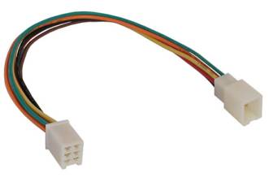
Male end, to the right
Female end, to the left
Cut wires here
CON-60 connector from ALL Electronics

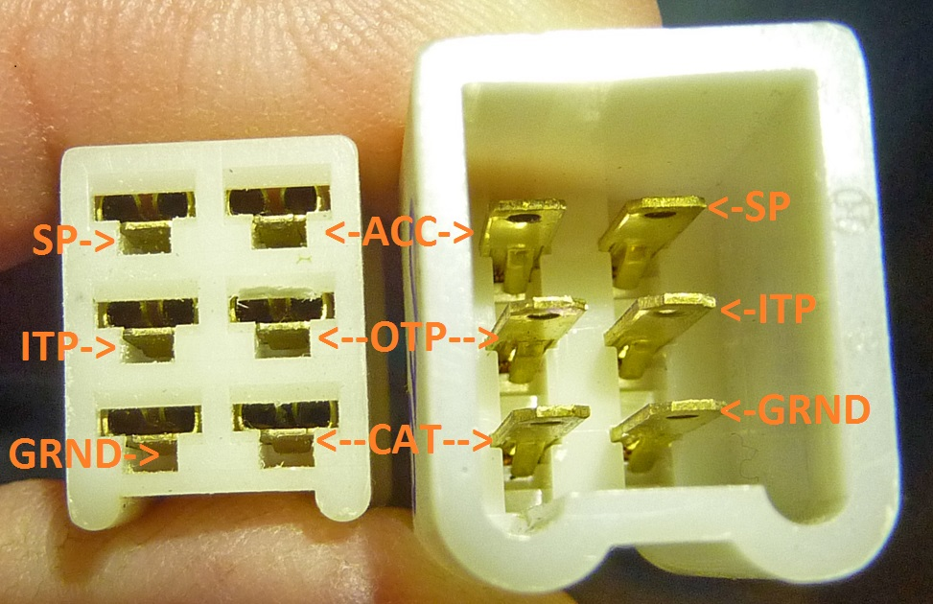

Female connector (as viewed looking at the end with index down):
Top Left = SP (Spare)
Top Right = ACC (Accessories)
Middle Left = ITP (Inside Track Power)
Middle Right = OTP (Outside Track Power)
Bottom Left = GRND (Ground)
Bottom Right = CAT (Catenary)

Male Connector (as viewed looking at the end with index down):
Top Left = ACC (Accessories)
Top Right = SP (Spare)
Middle Left = OTP (Outside Track Power)
Middle Right = ITP (Inside Track Power)
Bottom Left = CAT (Catenary)
Bottom Right = GRND (Ground)
---------------------------------------------------------------------------------------------------------

SECTION #3 CATENARY SPECIFICATION

Background
The ETE/GL has catenary installed on the two mainlines at least. Catenary can be installed everywhere at the builder’s discretion. As we run only digital on the inside mainline this catenary is mainly “for show”. Nevertheless, the catenary on the inside track should be electrically connected to the catenary buss so that it could be functional if ever needed. However, as we run analog on the outside mainline the catenary on the outside mainline track, this catenary wire meant to be totally functional. This means that whatever catenary system you choose to use must reliably carry sufficient current to operate the trains in a prototypical manner. We know that both the old and the new Marklin system meet these requirements. The Sommerfeldt system, because it’s soldered, should also work. The existing Viessmann system does not work well for functioning catenary and can only be used in places that are purely for show.

Rule #1 – The catenary masts
Marklin compatible masts must be installed at least at the following four places. When the rule says “beyond” it means towards the center of the module. Four masts must be installed on the two mainline tracks between the first and second tie (sleeper) beyond the location of two 094 and two 077 track pieces at each module interface to the outside world. The masts can be installed on the outside or inside of the mainline. For example, installation on the outside is shown in the drawing. Note that these specs are for both the old Marklin catenary system and the new.

End of 077 or 094
End of module
Catenary mast, both old and new style
End of 077 or 094

Rule #2 – The catenary wires
A standard Marklin adjustable catenary wire will be used to bridge the gap between two modules. Any wire length can be used in the interior of the module. It is absolutely essential that the wires be placed in between the rails of any track. A good rule of thumb would be that the catenary wire must be at least 2 mm away from the inside of any rail. Special attention to this detail is required at any turnout or crossing. The height of the wire above the track is determined by the use of the available masts.

________________________________________________________

SECTION #4 APPEARANCE SPECIFICATION

Rule #1 – The ground
The color to be used to represent “earth” or “dirt” is BROWN MOSS (Waverely Home Classics by Valspar – WV37012) available from Lowe’s. Get the paint in the matte variety. Paint the entire top surface of the module with this color. All additional landscaping and track roadbed is placed on top of this color.

Rule #2 – The roadbed
The roadbed consists of a 50% - 50% mixture of Woodland Scenics Fine Grey Blend with Woodland Scenics Fine Cinders. Place the roadbed according to the roadbed rules – see Module section – rule # 14. All tracks must have some manner of roadbed under them except for bridges and the like.

Rule #3 – Ground cover
The general appearance of ground cover is specified in an attempt to establish an overall consistent look to the modules. If your module appearance differs a lot from this rule the appearance at the module ends should adhere to this spec for the sake of visual continuity. The ground cover consists of a blend of two-thirds (by volume) of Woodland Scenics Blended Turf – Green Blend (T1349) with one-third Blended Turf – Earth Blend (T1350). Into this mix you can add various colors of weeds, flowers, etc as per your desired effect. I would make the ground cover nearest the tracks a little more “earthy” or yellowish to simulate weeds but that’s up to you.

Rule #4 – Front and rear of module
Paint both the front and rear face of the module flat black. This helps the module blend in with the skirting which is used on both the inside and outside of the layout.
============================================================

Please note that in the following examples the placement of the various pieces is for calculation purposes only. Except for the temporary 094 and the 077 end pieces, feel free to place all the rest anywhere in the module. Some typical “flat lander” modules viewed from inside the layout might be:

A. The “straight through special” made up as follows:
094 + (3 X 188) + (2 X 172) + (2 X 071) + 077 = 1221.6 mm, or
094 + (3 X 188) + 172 + (4 X 077) + 077 = 1218.3 mm

or a module with one normal radius turnout made up as follows:
- 094 + 611/12 (188) + (2 X 172) + (2 X 188) + (2 X 071) + 077 = 1221.6 mm

or two normal radii turnouts made up as follows:

094 + 611/12 (188) + (2 X 172) + 188 + 611/12(188) + (2 X 071) + 077 = 1221.6 mm

If you wanted to use a large radius turnout you might use:
- 094 + 711/12(236) + 071 + (2 X 236) + (2 X 064) + (2 X 071) + 077 = 1221 mm

N.B. These examples are only meaningful in a perfectly flat linear world. If you choose to include grade elevation changes or some other curve arrangement, you’re on your own. In spite of the “C” track “click to connect”, they can actually be pulled apart just a bit and then fastened down and still have good electrical conductivity as well as reliable operation. Curves can also be coaxed a bit into a slightly different curve. A builder of a “real world” module will probably have to resort to all of these tricks in order to get a module to come out to spec. at the ends.

----------------------------------------------------------------------------------------------------------

What follows are merely suggestions, not rules:

Suggestion #1:
As your budget allows, obtain at least one box each of the sizes listed in the Building Blocks section. You may wish to consider purchasing at least two boxes of the 188 and the 172, they tend to get used a lot. Buy turnouts as required. Ideally, the turnouts should be motorized for the layout. Do so if your budget allows. Manual turnouts are acceptable.

Suggestion #2
Find a nice shiny surface about 5 feet long on which to move pieces around on until you “get it right”. The “C” track pieces shouldn’t scratch any surface but be careful. Using masking tape or whatever else works, mark off a distance of 1221 mm on your nice shiny surface.

Suggestion #3
Put down a 094 to left end of the 1221 mm length and a 077 to the right end. Using the building blocks move the pieces around in between the 094 and the 077 until you have a 1221 mm length or reasonably close to it. (Rule #1)

Suggestion #4
Once you’re satisfied with your creation, cut your top surface (¼ inch ply?) to the exact length of your track creation, not to 1221 mm. Ideally your creation should be 1221 mm but if the layout, when assembled, can’t absorb a difference of a few millimeters difference in lengths of the overall sides, we’ve done something very wrong. Lay your track creation on the top of the module. Adjust the overall length of the module, not the track, to assure that the 094’s and the 077’s are at the exact edge of the wooden top or up to a 2 mm overhang on the left end. Use the end of the rail as the edge, not any plastic “connecty things” sticking out the ends. “But what if my inner and outer track lengths are not the same?” Good question – no answer except to say, “Don’t do that”. There is a certain amount of flexibility, including length, built into “C” track so you should be able to compensate for a millimeter or two difference INSIDE your module but the temporary end 094’s and 077’s must be exactly on the edge or up to 2 mm over on the left end.

Suggestion #5
Prepare the surface of the module as suggested in the appearance spec. Drill holes and attach wiring as required by the electrical spec.

Suggestion #6
Fasten the track to the base EXCEPT for the end 094’s and 077’s. These pieces were only used temporarily to determine the length. When we assemble the whole layout these 094’s and 077’s will be replaced by 172’s. EXCEPTION – You can permanently fasten the 094 to the module if it is a 094 temporary connection track for signaling or the like.

Suggestion #7
Add buildings, scenery, lots of people, etc. to bring your model world to life.

------------------------------------------------------------------------------------------------------

REVISION CHANGE RECORD

REV A – Original version (never formally released)

REV B – circulated for review on 6/26/04

REV C – released on 10/17/09
- Removed references to counterbore on end pieces, Rule #3 – Section #1, as they are no longer needed.
- Cleaned up drawing Fig. #1 in Section #1
- Added specification for new style Marklin catenary in Section #3.
- Cleaned up Section #3 on catenary
- Revised Rule #8 in Section #1 on allowing modules to extend into the operator area but only with prior approval.
- Added Rule #4 in Section #4 on painting the front and rear of the modules flat black

REV D – released 23 September 2015
- Revised Section #4 – Rule #3 – Groundcover to give examples of which Woodland Scenics ground cover to use.

REV E – released 27 January 2016
Revised Section #2 – Rule #1 The BUSS
Because the source of the CON-60 connector, All Electronics, has changed the colors of the wires , the spec has been rewritten to show the proper buss connections relative to the position of the pins on the connectors.

